基礎環境設定
pom.xml
<dependency>
<groupId>com.google.code.gson</groupId>
<artifactId>gson</artifactId>
<version>2.9.0</version>
</dependency>
<dependency>
<groupId>javax.servlet</groupId>
<artifactId>jstl</artifactId>
<version>1.2</version>
</dependency>

<dependency>
<groupId>mysql</groupId>
<artifactId>mysql-connector-java</artifactId>
<version>8.0.33</version>
</dependency>
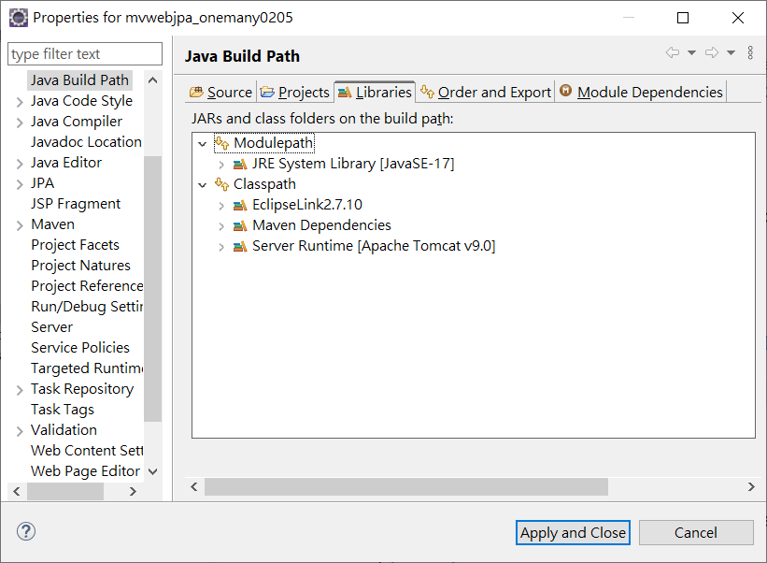
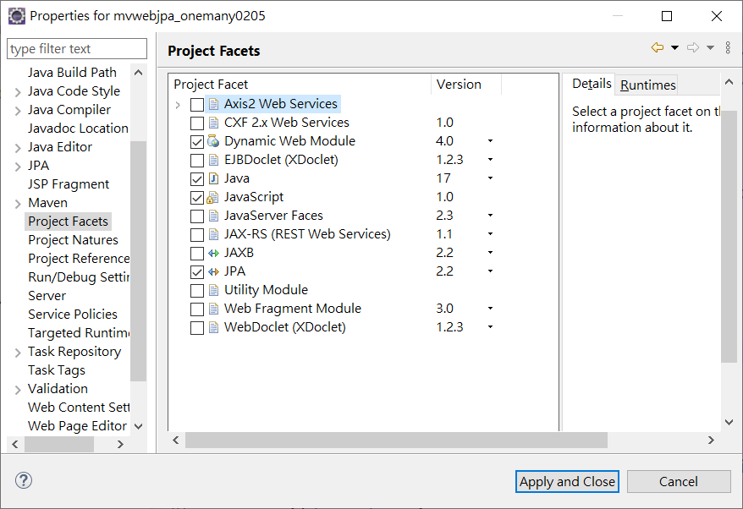
persistence.xml:
<?xml version="1.0" encoding="UTF-8"?>
<persistence version="2.2" xmlns="http://xmlns.jcp.org/xml/ns/persistence" xmlns:xsi="http://www.w3.org/2001/XMLSchema-instance" xsi:schemaLocation="http://xmlns.jcp.org/xml/ns/persistence http://xmlns.jcp.org/xml/ns/persistence/persistence_2_2.xsd">
<persistence-unit name="mvwebjpa0205" transaction-type="RESOURCE_LOCAL">
<class>model.Employee</class>
<class>model.Office</class>
<properties>
<property name="javax.persistence.jdbc.url" value="jdbc:mysql://localhost:3306/classicmodels"/>
<property name="javax.persistence.jdbc.user" value="root"/>
<property name="javax.persistence.jdbc.password" value="1234"/>
<property name="javax.persistence.jdbc.driver" value="com.mysql.cj.jdbc.Driver"/>
</properties>
</persistence-unit>
</persistence>

OneToMany 1對多單向設定

Office.java

import java.io.Serializable;
import java.util.List;
import javax.persistence.*;

@Entity
@Table(name="offices")
@NamedQuery(name="Office.findAll", query="SELECT o FROM Office o")
public class Office implements Serializable {
private static final long serialVersionUID = 1L;

@Id
private String officeCode;

private String addressLine1;

private String addressLine2;

private String city;

private String country;

private String phone;

private String postalCode;

private String state;

private String territory;

@OneToMany(cascade = CascadeType.ALL)
@JoinColumn(name="officeCode")
private List<Employee> employees;

public Office() {
}

public String getOfficeCode() {
return this.officeCode;
}

public void setOfficeCode(String officeCode) {
this.officeCode = officeCode;
}

public String getAddressLine1() {
return this.addressLine1;
}

public void setAddressLine1(String addressLine1) {
this.addressLine1 = addressLine1;
}

public String getAddressLine2() {
return this.addressLine2;
}

public void setAddressLine2(String addressLine2) {
this.addressLine2 = addressLine2;
}

public String getCity() {
return this.city;
}

public void setCity(String city) {
this.city = city;
}

public String getCountry() {
return this.country;
}

public void setCountry(String country) {
this.country = country;
}

public String getPhone() {
return this.phone;
}

public void setPhone(String phone) {
this.phone = phone;
}

public String getPostalCode() {
return this.postalCode;
}

public void setPostalCode(String postalCode) {
this.postalCode = postalCode;
}

public String getState() {
return this.state;
}

public void setState(String state) {
this.state = state;
}

public String getTerritory() {
return this.territory;
}
public void setTerritory(String territory) {
this.territory = territory;
}
public List<Employee> getEmployees() {
return employees;
}
public void setEmployees(List<Employee> employees) {
this.employees = employees;
}
}

Employee.java

import java.io.Serializable;
import javax.persistence.*;

@Entity
@Table(name="employees")
@NamedQuery(name="Employee.findAll", query="SELECT e FROM Employee e")
public class Employee implements Serializable {
private static final long serialVersionUID = 1L;

private String email;
@Id
private int employeeNumber;

private String extension;

private String firstName;

private String jobTitle;

private String lastName;

private int reportsTo;

private String officeCode;

public Employee() {
}

public String getEmail() {
return this.email;
}

public void setEmail(String email) {
this.email = email;
}

public int getEmployeeNumber() {
return this.employeeNumber;
}

public void setEmployeeNumber(int employeeNumber) {
this.employeeNumber = employeeNumber;
}

public String getExtension() {
return this.extension;
}

public void setExtension(String extension) {
this.extension = extension;
}

public String getFirstName() {
return this.firstName;
}

public void setFirstName(String firstName) {
this.firstName = firstName;
}

public String getJobTitle() {
return this.jobTitle;
}

public void setJobTitle(String jobTitle) {
this.jobTitle = jobTitle;
}
public String getLastName() {
return this.lastName;
}
public void setLastName(String lastName) {
this.lastName = lastName;
}
public int getReportsTo() {
return this.reportsTo;
}
public void setReportsTo(int reportsTo) {
this.reportsTo = reportsTo;
}
public String getOfficeCode() {
return officeCode;
}
public void setOfficeCode(String officeCode) {
this.officeCode = officeCode;
}
}

OfficeDAO.java

import java.util.*;
import javax.persistence.*;
public class OfficeDAO {
public static List<Office> getAll(){
List<Office> data=new ArrayList<>();
try {
EntityManagerFactory factory=Persistence.createEntityManagerFactory("mvwebjpa0205");
EntityManager mgr=factory.createEntityManager();
Query q=mgr.createQuery("select s from Office s");
List values=q.getResultList();
data=(List<Office>)values;
}catch(Exception ex) {
System.out.println("Error in OfficeDAO getAll:"+ex.getMessage());
}

return data;
}
}

OfficeServlet:
protected void doGet(HttpServletRequest request, HttpServletResponse response) throws ServletException, IOException {

List<Office> data=OfficeDAO.getAll();
Gson gson=new Gson();
String jstr=gson.toJson(data);
response.setContentType("application/json;chrset=utf-8");
response.getWriter().append(jstr);
}

ManyToOne多1對單向設定
Office.java

import java.io.Serializable;
import java.util.List;
import javax.persistence.*;
@Entity
@Table(name="offices")
@NamedQuery(name="Office.findAll", query="SELECT o FROM Office o")
public class Office implements Serializable {
private static final long serialVersionUID = 1L;

@Id
private String officeCode;

private String addressLine1;

private String addressLine2;

private String city;

private String country;

private String phone;

private String postalCode;

private String state;

private String territory;

// @OneToMany(cascade = CascadeType.ALL)
// @JoinColumn(name="officeCode")
// private List<Employee> employees;

public Office() {
}

public String getOfficeCode() {
return this.officeCode;
}

public void setOfficeCode(String officeCode) {
this.officeCode = officeCode;
}

public String getAddressLine1() {
return this.addressLine1;
}

public void setAddressLine1(String addressLine1) {
this.addressLine1 = addressLine1;
}

public String getAddressLine2() {
return this.addressLine2;
}

public void setAddressLine2(String addressLine2) {
this.addressLine2 = addressLine2;
}

public String getCity() {
return this.city;
}

public void setCity(String city) {
this.city = city;
}

public String getCountry() {
return this.country;
}

public void setCountry(String country) {
this.country = country;
}

public String getPhone() {
return this.phone;
}

public void setPhone(String phone) {
this.phone = phone;
}

public String getPostalCode() {
return this.postalCode;
}

public void setPostalCode(String postalCode) {
this.postalCode = postalCode;
}

public String getState() {
return this.state;
}

public void setState(String state) {
this.state = state;
}

public String getTerritory() {
return this.territory;
}

public void setTerritory(String territory) {
this.territory = territory;
}

// public List<Employee> getEmployees() {
// return employees;
// }
//
// public void setEmployees(List<Employee> employees) {
// this.employees = employees;
// }

}

Employee.java
import java.io.Serializable;
import javax.persistence.*;

/**
* The persistent class for the employees database table.
*
*/
@Entity
@Table(name="employees")
@NamedQuery(name="Employee.findAll", query="SELECT e FROM Employee e")
public class Employee implements Serializable {
private static final long serialVersionUID = 1L;

private String email;
@Id
private int employeeNumber;

private String extension;
private String firstName;
private String jobTitle;
private String lastName;
private int reportsTo;

//uni-directional many-to-one association to Office
@ManyToOne
@JoinColumn(name="officeCode")
private Office office;

public Employee() {
}

public String getEmail() {
return this.email;
}

public void setEmail(String email) {
this.email = email;
}

public int getEmployeeNumber() {
return this.employeeNumber;
}

public void setEmployeeNumber(int employeeNumber) {
this.employeeNumber = employeeNumber;
}

public String getExtension() {
return this.extension;
}

public void setExtension(String extension) {
this.extension = extension;
}

public String getFirstName() {
return this.firstName;
}

public void setFirstName(String firstName) {
this.firstName = firstName;
}

public String getJobTitle() {
return this.jobTitle;
}

public void setJobTitle(String jobTitle) {
this.jobTitle = jobTitle;
}

public String getLastName() {
return this.lastName;
}

public void setLastName(String lastName) {
this.lastName = lastName;
}

public int getReportsTo() {
return this.reportsTo;
}

public void setReportsTo(int reportsTo) {
this.reportsTo = reportsTo;
}

public Office getOffice() {
return this.office;
}

public void setOffice(Office office) {
this.office = office;
}

}

EmployeeDAO.java
import java.util.*;
import javax.persistence.*;
public class EmployeeDAO {
public static List<Employee> getAll(){
List<Employee> data=new ArrayList<>();
try {
EntityManagerFactory factory=Persistence.createEntityManagerFactory("mvwebjpa0205");
EntityManager mgr=factory.createEntityManager();
Query q=mgr.createQuery("select s from Employee s");
List values=q.getResultList();
data=(List<Employee>)values;
}catch(Exception ex) {
System.out.println("Error in EmployeeDAO getAll:"+ex.getMessage());
}

return data;
}
}

EmployeeServlet.java
protected void doGet(HttpServletRequest request, HttpServletResponse response) throws ServletException, IOException {
// TODO Auto-generated method stub
//response.getWriter().append("Served at: ").append(request.getContextPath());
List<Employee> data=EmployeeDAO.getAll();
data=data.stream().filter(e->e.getOffice().getCity().equalsIgnoreCase("Tokyo")).collect(Collectors.toList());
Gson gson=new Gson();
String jstr=gson.toJson(data);
response.setContentType("application/json;chrset=utf-8");
response.getWriter().append(jstr);
}

